Welcome Back to _________ Presbyterian Church!

We are so glad to have you back in the sanctuary for worship. We assure you we are taking every step possible to provide the safest possible experience here at ____________ Presbyterian Church. To help us all take care of each other as we come back together in-person, we ask you list the members of your family attending today and to affirm the statements below with your signature (one per household).

Members of my household attending worship today:

I hereby affirm:

* In the last 14 days, no one in my household has been diagnosed with Covid19.
* In the last 14 days, no one in my household has come into contact with anyone who has been diagnosed with Covid19.
* In the last 14 days, no one in my household has experienced the onset of any of the following symptoms: fever, cough, shortness of breath, headache, muscle aches, fatigue, loss of taste or smell, nausea, vomiting, or diarrhea.
* By attending a public gathering for worship, I assume the risk of possible exposure to Covid19 and agree to hold harmless _______________ Presbyterian Church for any consequence resulting from that exposure.
* The members of my household will follow the guidelines for returning to worship adopted by the ______________ Presbyterian Church Session including social distancing and proper mask-wearing while on the church campus.

Signature:

Date: Phone Number:

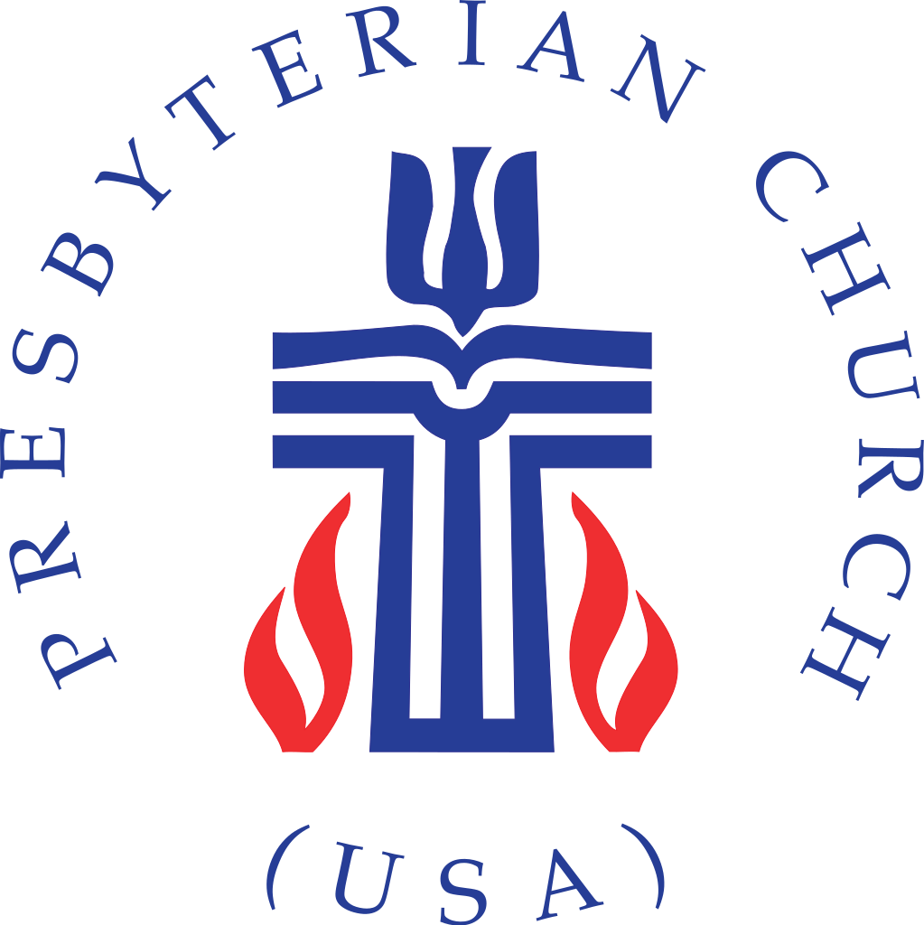

**“We are the ONE BODY of Christ and individually members of it.” *-1 Corinthians 12:27***